Disaccharides
There are 3 main disaccharides: maltose, lactose and sucrose.

They are formed by a condensation reaction, and therefore can be broken down through a hydrolysis reaction.

This means the reactions to form them are reversible.

The glycosidic bonds indicate which carbons are joined, e.g. a 1-4 glycosidic bond is between carbons 1 and 4.

They all have the formula C₁₂H₂₂O₁₁

Maltose
- Glucose + glucose
- Broken down in the body by maltase
- Found mostly in seeds
- Joined by a 1-4 glycosidic bond
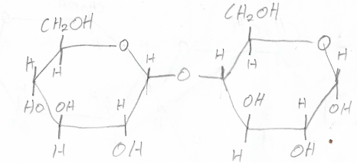

Lactose
- Glucose + galactose
- Broken down in the body by lactase
- Found mostly in milk
- Joined by a 1-4 glycosidic bond
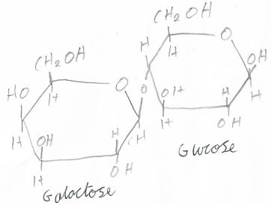

Sucrose
- Glucose + fructose
- Broken down in the body by sucrase
- Found mostly as table sugar
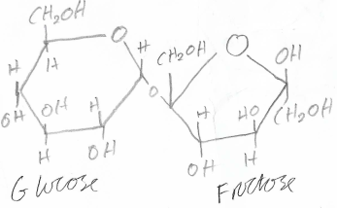
- Joined by a 1-2 glycosidic bond

